Contestant Number:
Time:
Rank:


JAVA PROGRAMMING
(340)

NATIONAL 2020

Production Portion:

Program 1: Fun Shapes (300 points)

TOTAL POINTS (300 points)

Failure to adhere to any of the following rules will result in disqualification:
- Contestant must hand in this test booklet and all printouts. Failure to do so will result in disqualification.
- No equipment, supplies, or materials other than those specified for this event are allowed in the testing area. No previous BPA tests and/or sample tests or facsimile (handwritten, photocopied, or keyed) are allowed in the testing area.
- Electronic devices will be monitored according to ACT standards.

No more than ten (10) minutes orientation
No more than ninety (90) minutes testing time
No more than ten (10) minutes wrap-up

Property of Business Professionals of America.
May be reproduced only for use in the Business Professionals of America
Workplace Skills Assessment Program competition.

You will have 90 minutes to complete your work.

Your name and/or school name should not appear on any work you submit for grading. Write your contestant number in the provided space. Staple all pages in order before you turn in your test.

To submit your project:
- Create a folder on the flash drive using your contestant number as the name of the folder.
- Copy your entire solution/project into this folder, including source code.
- Ensure all the files required to run your program are present on the flash drive and will run on the flash drive.

Use the default package for the Java projects you create.

Fun Shapes

You have been hired by HasKids to create a small game for kids to play. This game lets kids click a button to create a random shape with a random color that appears in the game. They can also clear the screen of all shapes as well as toggle between filled shapes and outlined shapes.

General requirements:
- You must use JavaDoc for all methods in your program. It must cover what the method does and the inputs and outputs if there are any. JavaDoc is not required on the classes or variables.
- Your contestant number must appear in a comment near the top of your main class file, somewhere before the start of the main class.

Button requirements:
- All 3 buttons should be at the bottom of the window.
- The left button (Add Shape button) should add 1 shape to the screen. The shape’s requirements are listed below.
- The middle button (Clear button) should remove all shapes from the screen so that the next time the kid adds a shape, that shape will be the only one on the screen.
- The right button (Outline Mode button) should be a toggle button that, when enabled, makes all shapes, existing and new, be drawn as outlines. When the toggle button is disabled, all shapes, existing and new, should go back to being drawn filled. The button should start disabled (filled-in mode).

Shape requirements:
- Each shape should randomly be a circle or square when it is created.
- Each shape should have a completely random color with no transparency (alpha).
- The shapes should all have a random size. Choose values that make it obvious that the size and position are randomized.
- The shapes should be drawn above the buttons and should not overlap any buttons or go off-screen. They should be able to touch the edges of the canvas, though.

The main class of the program will be called Shapes.

Code requirements:
- You must use a SINGLE ArrayList to store the shapes (circles and squares). This keeps the overlapping order correct when drawing.
- You must use an ArrayList to store the shapes’ colors as java.awt.Color objects. The number of colors will match the number of shapes.
- The circles should be Ellipse2D.Float objects.
- The squares should be Rectangle2D.Float objects.

Sample Run

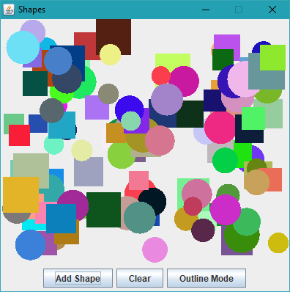

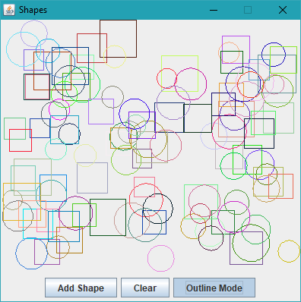

Your program will be graded on the following criteria:

Solution and Project

The project is present on the flash drive. 10 points
The project’s main class is called Shapes. 10 points

Program Execution

The program runs from the USB flash drive. 10 points

If the program does not execute, then the remaining items in this section receive a score of zero.

All 3 buttons are present at the bottom of the window. 15 points

The Add Shape button creates shapes (no randomization required) and draws them on the canvas. 20 points
The shapes created have random sizes. 15 points
The shapes created have random locations. 15 points
The shapes created have random colors. All hues should be possible. 15 points
The shapes are randomly chosen between circle and square. 15 points
There is no transparency in any shapes when filled in. 10 points
The shapes never overlap a button and do not go off-screen. 20 points

The Clear button removes all shapes from the screen. 10 points
Adding a shape after clicking the Clear button only shows 1 shape, not any previously shown shapes, in the same drawing mode as before. 10 points

The Outline Mode button is a toggle button, not a regular button. 10 points
Enabling Outline Mode makes all shapes, existing and new, show only their outlines. 15 points
Disabling Outline Mode makes all shapes, existing and new, draw the shapes filled in. 15 points

Source Code Review

The contestant number is in a comment above the start of the main class. 10 points

A single ArrayList is used to store the list of shapes. 30 points
A single ArrayList<java.util.Color> is used to store the shapes’ colors. 15 points

JavaDoc is used to cover what each method does and the inputs and outputs if there are any. Not required on classes and variables. 30 points

Total Points = / 300 points

